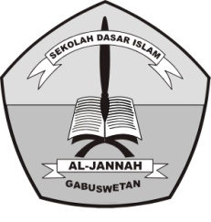**PENILAIAN TENGAH SEMESTER (PTS) GANJIL**

**TAHUN PELAJARAN 2018/2019**

SD ISLAM AL-JANNAH

**Jl. Raya Gabuswetan No. 01 tlp (0234) 5508501**

**Desa Gabuswetan Kecamatan Gabuswetan – Indramayu 45263**

**Email : sdi.aljannah@gmail.com Website :http://www.sdi-aljannah.web.id**

Nama : Hari / Tanggal : , September 2018

Kelas : III (Tiga) Mata Pelajaran : Bahasa Inggris

1. **Berilah tanda silang (X) pada huruf A, B, C, atau D di depan jawaban yang dianggap paling benar!**
2. “Reading” In indonesian is …

a. Menulis c. Berbicara

b. Mendengarkan d. Membaca

1. A : Hi, Merlin. I’m Angel Nice to meet you

B : ……….Angel.

a. Nice to meet you

b. Nice to meet you too

c. I am ok. Thanks

d. How are you?

1. A : Hi, Deni. How are you?

B : ……thanks

* 1. Nice to meet you too c. I am fine
  2. Nice to meet you d. Hello

1. A : What is your.....?  
   B : I am Ali

a. old c. how

b. name d. they

1. A : How .....are you:  
   B : I am 9 years old.
2. is c. old
3. are d. name
4. A : Good evening, Anisa.

B : ………. Angie.

* 1. Good morning c. Good afternoon
  2. Good Evening d. Good night

1. A : I’m sorry. I’m..... (terlambat)

B : Its okay

a. name c. old

b. late d. thanks

1. We are watching ... in the living room.
   1. Television c. radio
   2. Telephone d. clock
2. PKN in English is.....
   * + 1. Civic c. sports
       2. Arts d. religion
3. A : I’m sorry. I lost your pencil.

B : .......

1. I am fine c. They are not
2. Its okay d. It is not
3. When does he watch TV?

He watch TV at.....

a. four o’clock

b. five o’clock

c. six o’clock

d. seven o’clock

1. When does he take a nap?

He take a nap at.....

1. 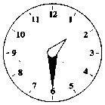Half past one
2. Half past two
3. Half past three
4. Half past four
5. IPA in English is.....
6. Social science c. arts
7. Sports d. science
8. Social Science in Indonesia is.....
9. IPS c. IPA
10. PKN d. PAI
11. Amel is……in the river.  
     a.surfing c. swimming

b.diving d. fishing

1. Adi : What time is it?

Bio : its 12.30

* 1. Half past one
  2. Half past twelve
  3. Twelve o’clock
  4. Quarter past twelve

1. My hobby is …

a. Cooking

b. swimming

c. painting

dancing

1. My hobby is……in the river.  
    a.surfing c. swimming

b.diving d. fishing

1. A : What’s your hobby?

B : My hobby is,……….

* 1. Dancing
  2. Singing
  3. Painting
  4. Writing

1. A : What’s your hobby?

B : My hobby is,……….

* 1. Dancing
  2. Singing
  3. Painting
  4. Writing

1. **Isilah titik-titik di bawah ini dengan tepat!**



1. My hobby is …..



1. I am hungry. I want…..

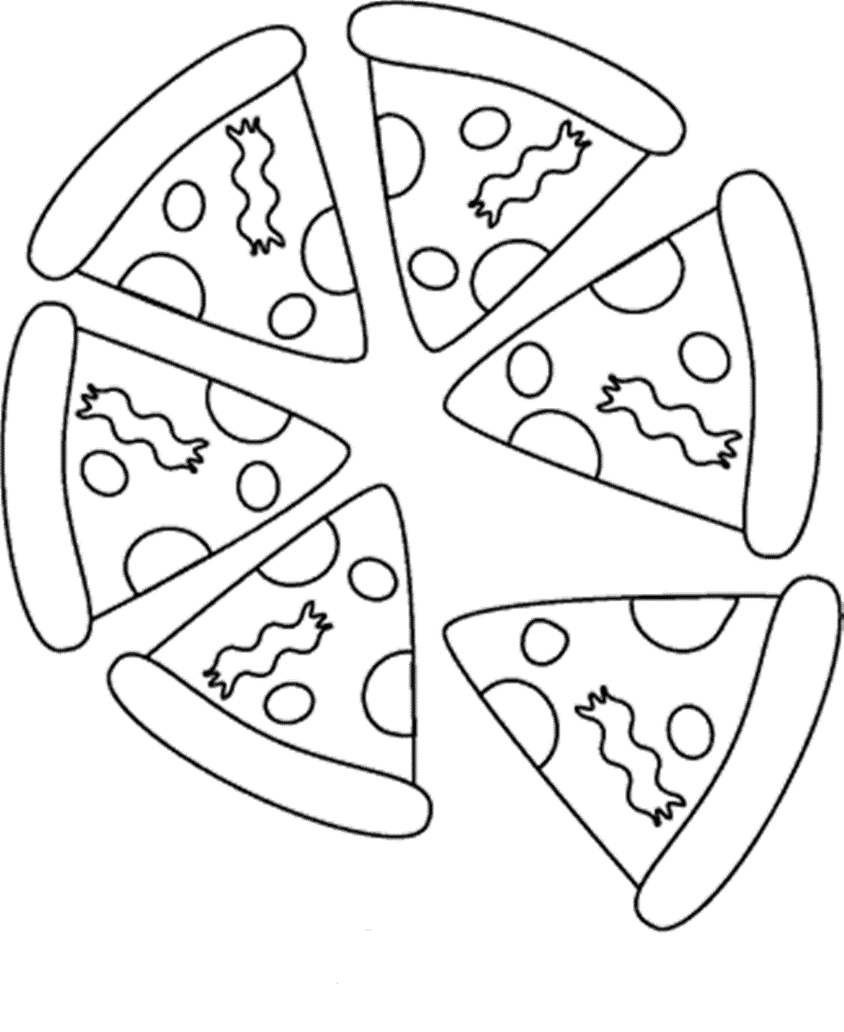

1. I am hhungry. I want…..



1. My hobby is ……

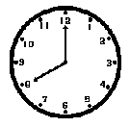

1. What time is it?

It is…….

Irfan’s Busy Days

Monday is a busy day for Irfan.

He gets up at five o’clock on that day. After that he takes a bath and gets dressed. He has breakfast at six o’clock. At half past six he goes to school with his sister. He finishes his school at two afternoons. He gets home at half past two. Han he has karate class at four o’clock. He has diner at seven evening. At half past seven he has piano class until nine. He goes to bed at nine. Monday is a very busy day, but Irfan like it.

1. Irfan and his sister…..at half past six
2. He has breakfast at…..
3. He gets home at…..
4. Irfan has karate class at…..
5. He has…..at seven evening